Week 15

Question 1:
Given an array of integers, reverse the given array in place using an index and loop rather than a built-in function.
Example
arr = [1, 3, 2, 4, 5]
Return the array [5, 4, 2, 3, 1] which is the reverse of the input array.
Function Description
Complete the function reverseArray in the editor below.
reverseArray has the following parameter(s):
int arr[n]: an array of integers
Return: int[n]: the array in reverse order
Input Format:
The first line contains an integer, n, the number of elements in arr.
Each line i of the n subsequent lines (where 0 ≤ i < n) contains an integer, arr[i].
Program:
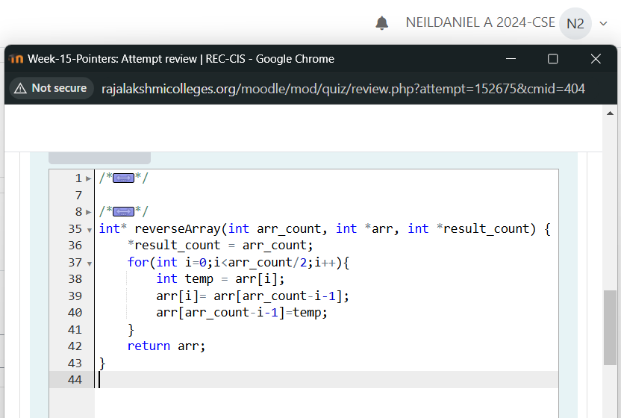
Output:
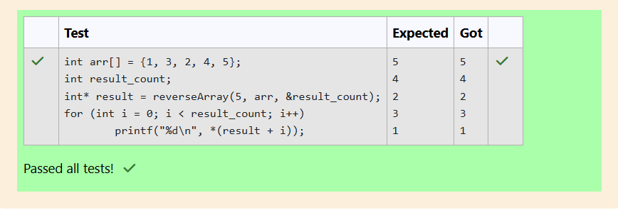
Question 2:
An automated cutting machine is used to cut rods into segments. The cutting machine can only hold a rod of minLength or more, and it can only make one cut at a time.
Given the array lengths[] representing the desired lengths of each segment, determine if it is possible to make the necessary cuts using this machine. The rod is marked into lengths already, in the order given.
Input Format:
The first line contains an integer, n, the number of elements in lengths.
Each line i of the n subsequent lines (where 0 ≤ i < n) contains an integer, lengths[i]. T
he next line contains an integer, minLength, the minimum length accepted by the machine.
Program:
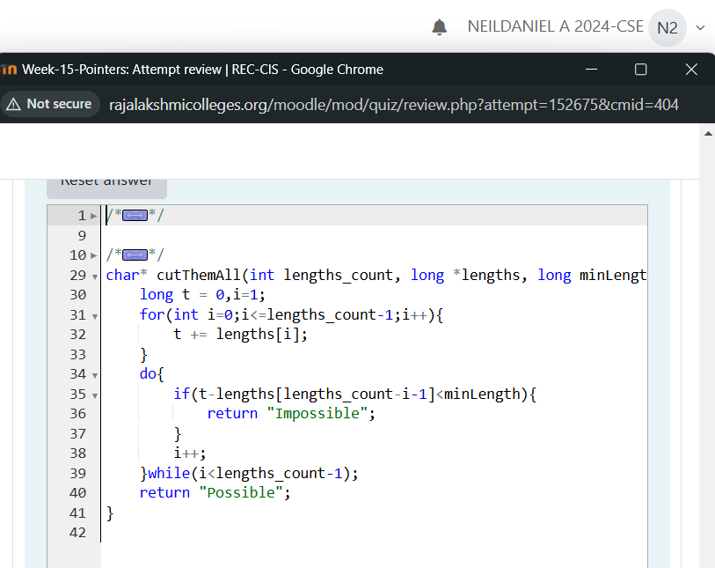
Output:
